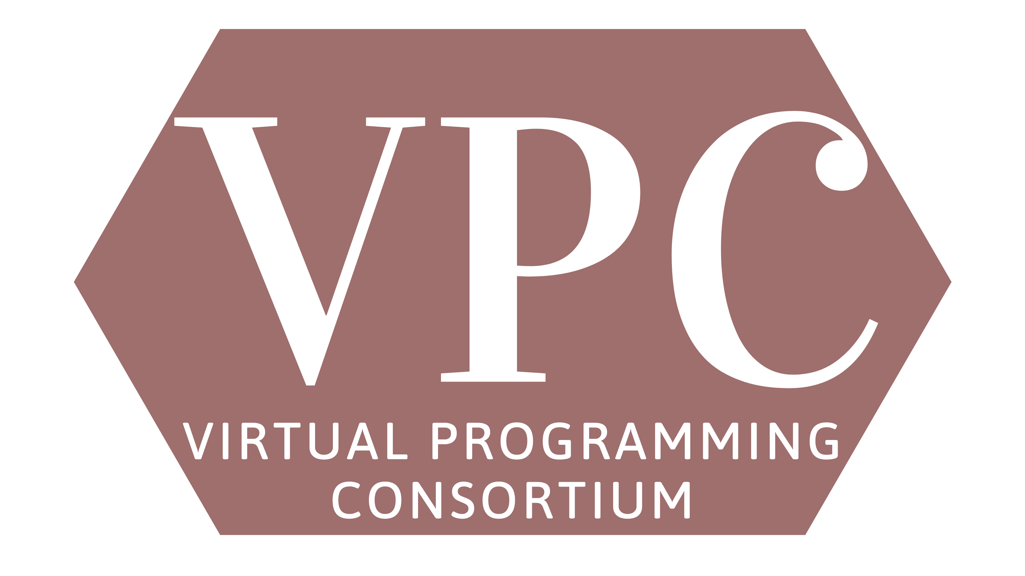

Author in the Spotlight Chris Bohjalian Zoom Event Wednesday, Oct. 27, 6:30 PM

Library Name __________________________________________
Library Address __________________________________________
__________________________________________

Contact Name __________________________________________
Contact Email __________________________________________

Note: $1.50 is the absolute maximum cost per seat your library will pay to participate. The Zoom license maximum capacity is 5,000, which would bring the cost per seat down to $0.50.
Deadline for participation is Wednesday, Oct. 13, or until supplies last.
Please email this completed order form to Jesse Blazek at palos.library@phlibrary.org.

